Subject Data structure & Algorithm in C language

Program1:- Write A Program to Perform linear Search on Array

//Q1a linear Search using Fanction;

#include<stdio.h>

int linearSearch(int arr[],int size,int element){

  for (int i = 0; i < size; i++)

  {

    if (arr[i]==element)

    {

      return i;

    }

  }

  return -1;

}

int main(){

  int arr[100],element,n;

  printf("Enter Size of Array: ");

  scanf("%d",&n);

  printf("Enter Array Elements: ");

  for (int i = 0; i <n; i++)

  {

    scanf("%d",&arr[i]);

  }

  int size=sizeof(arr)/sizeof(int);

  printf("Enter Element you want to Search in Array ");

  scanf("%d",&element);

  int SearchIndex = linearSearch(arr,size,element);

  printf(" element %d was found at index %d \n",element,SearchIndex);

  return 0;

}

Output:-

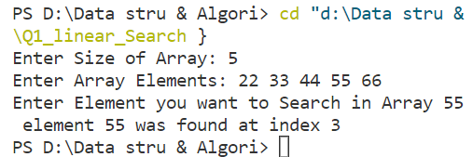

Program2:- Write A Program to Perform Binary Search on Array

#include<stdio.h>

int binarySearch(int arr[],int size,int element){

     int beg,mid,end;

     beg=0;

    end=size-1;

    while (beg<=end){

        mid = (beg+end)/2;

        if (arr[mid]==element)

        {

            return mid;

        }

        else if(arr[mid]<element){

            beg = mid+1;

        }else{

            end = mid -1;

        }

    }

    return -1;

}

int main(){

    int arr[100],n,element;

    printf("Enter Size of Array: ");

    scanf("%d",&n);

    printf("Enter Array Elements ");

    for (int i = 0; i <n; i++){

        scanf("%d ",&arr[i]);

    }

    scanf("%d",&element);

    int searchIndex;

    searchIndex = binarySearch(arr,n,element);

    printf("Element %d,was found at %d",element,searchIndex);

    return 0;

}

Output:-

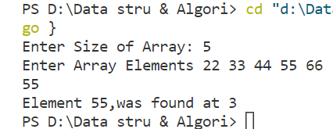

Program3:- Write a program to implement/Perform Insertion on Array

#include<stdio.h>

void display(int arr[], int size){

    for (int i = 0; i<size; i++)

    {

        printf("%d ",arr[i]);

    }

    printf("\n");

}

int Insertion(int arr[],int size,int position,int element){

    for (int i = size-1; i>=position-1; i--)

    {

        arr[i+1] = arr[i];

    }

    arr[position-1]=element;

}

int main(){      //n = size of Array

    int arr[100],n,i,j,pos,element; //position is nothing

    printf("Enter Array Size: ");   // index = pos -1; becouse your user don't no Array index

    scanf("%d",&n);

    printf("Enter Array element: ");

    for (int i = 0; i <n; i++){

        scanf("%d",&arr[i]);

    }

    printf("Enter position of Array you want to insert element: ");

    scanf("%d",&pos);

    printf("Enter element of Array you want to insert: ");

    scanf("%d",&element);

    Insertion(arr,n,pos,element);

    n++;

    printf("Result of Array: ");

    display(arr,n);

    return 0;

}

Output:-

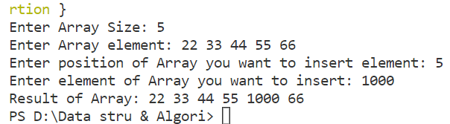

Program 4:- Write a program to implement deletion on Array

#include<stdio.h>

void  DISPLAY( int arr[],int n){

    for (int i = 0; i < n; i++){

        printf("%d ",arr[i]);

    }

    printf("\n");

}

int Deletion_ele(int arr[],int pos,int size){

    for (int i = pos-1; i <=size-1 ; i++){

        arr[i] = arr[i+1];

    }

}

int main(){

    int arr[100],n,pos;

    printf("Enter Size of Array: ");

    scanf("%d",&n);

    printf("Enter Array element: ");

    for (int i = 0; i <n; i++){

        scanf("%d",&arr[i]);

     }

    printf("Enter Position of Array you want to delete: ");

    scanf("%d",&pos);

    Deletion_ele(arr,pos,n);

    n--;

    DISPLAY( arr, n);

    return 0;

}

//     //size -1 (n-1) is nothing

//     //but when we start array

//     // with 0 so we take n-1

Output:-

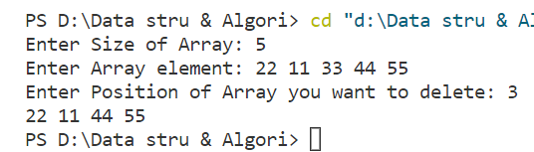

Program 5:- Write a program to implement Bubble Sort in Array

#include <stdio.h>

void Display(int arr[], int Size)

{

    for (int i = 0; i < Size; i++)

    {

        printf("%d ", arr[i]);

    }

    printf("\n");

}

int main()

{

    int arr[100],n;

    printf("Enter Size of Array: ");

    scanf("%d",&n);

    printf("Enter element of array: ");

    for (int i = 0; i <n; i++)

    {

        scanf("%d",&arr[i]);

    }

    Display(arr, n);

    // bubble Sort;

    int temp;

    for (int i = 0; i < n - 1; i++) // no of pass

    // if we have 6 element of Array

    // then no of pass(it mean's layer of steps) is 5

    // so we use n-1; where n is size of Array

    {

        for (int j = 0; j < n - 1 - i; j++) // for no of comparison

        // it mean 1 ke liye n-1 comparison

        // it mean 2 ke liye n-2 comparison

        // it mean 3 ke liye n-3 comparison

        // it for n ke liye n-1-i comparison  where i=0;

        {

            if (arr[j] > arr[j + 1])

            {

                int temp;

                temp = arr[j];       // arr[j] first element of array

                arr[j] = arr[j + 1]; // arr[j+1] next element of Array

                arr[j + 1] = temp;

            }

        }

    }

    Display(arr, n);

    return 0;

}

Output:-

